Brighton and Hove Proactive Care
Contingency Planning Reflections
January 2017
Dr Esme Gates Proactive Care GP Cluster 6

Introduction

This paper has been developed based on the experience, audit and reflections of implementing Contingency Plans over an eight month period. The observations made in the report are derived from four case studies, the details of which have been removed due to sensitive information that could enable the persons to be identified. Through examining these cases, it is apparent that locally people are sometimes being set on an acute medical pathway which is counter to their expressed wishes and needs. The reflections made are intended to help with the further implementation of contingency planning by examining current provision.

Contingency planning is the term used to describe making a plan with the patient for response in case of illness. Central to this process is the patient’s wishes and goals. Similar work is described as advanced care planning but traditionally this is usually done for patients with predictable end of life decline. Our contingency planning work, which is led by a Proactive GP, aims to start this discussion early with all our patients whether they have a terminal diagnosis or not. Contingency plans are not legally binding (unlike advanced decisions or directives which are). To clarify further, a contingency plan, as we use the term, is a record of patient’s wishes, an advanced decision (AD) is a legally binding instruction and a Lasting Power of Attorney (LPA) is a legally appointed person to make decisions on someone’s behalf. There are conditions attached to an AD and LPA which can be easily referenced online, and it can be costly (I was quoted £800 last week to set up a single LPA).

The report is not a commentary on the involvement or impact of the Proactive Care Coaches but is based on four cases which have been enlightening and educational in developing contingency planning work. No criticism of any individual or practitioner is intended.
The three Proactive Care GPs involved all have access to upload plans on the SECAmb IBIS (South East Coast Ambulance Service Intelligence Based Information System) system and receive alerts when these patients dial 999. Currently I have 37 live contingency plans on SECAMB IBIS network meaning they are accessible to paramedics digitally via the 999 control room. A further six plans have been uploaded, but have since been removed as the patients sadly died.

I have audited each conveyance to hospital for all of these patients with the aim of describing what might have allowed them to stay at home, if wanted. Other Proactive Care GPs are also doing this audit.

The need for multi-disciplinary co-operation between providers

We have not been able to secure urgent, timely input from other providers for the proactive work - for example community physiotherapy, because staff have not been freed up to be part of the Proactive Care team or given permission to respond in a timely way. Even in a crisis there are workforce capacity issues; on one occasion in January 2017, Community Rapid Response Service (CRRS) would not have been able to support our patient when I called them because they were completely full.

Without a strong foundation of timely, multi-disciplinary working it is hard to demonstrate the theory that supporting people’s infrastructure at home will reduce their crisis. In one of the cases studied, a minor incident of a fall may well have escalated into a major crisis (for example from a long-lie) without support of the in-house care the person was able to privately afford.

The holy grail of admission avoidance is not achievable without co-operation across all agencies and sufficient workforce to provide care and support in a crisis. This is not the environment in which Proactive Care is currently working. There continues to be a strong culture in medicine and society at large that “hospital is best” and with admissions projected to increase because of changing population structure and cuts to social care it is more realistic that work in this area may, at best, slow the escalation.

The need for person centered contingency planning

Patients’ own needs and goals must be central to our work and their autonomy respected. This is not what I have found with the patients I have seen. Some patients are certain they would prefer to stay at home even if it shortens their life. Others want to go to hospital to see if they can get better.

Establishing ceilings of care for people is extremely difficult and I do not see contingency planning as a process to persuade patients. Indeed, to do so risks twisting this beneficial work, and attempts to minimise unwanted intervention and harm, into a rationing discussion. We have seen how the Liverpool Care Pathway was misused and became a scandal – patients and families received inadequate explanation and some hospitals had monetary incentives. This over-simplification should be guarded against in contingency planning work in Brighton & Hove. The case studies I looked at illustrate that patients are entering an unwanted acute medical pathway.

There is a gradient of ease when discussing contingency planning, as the diagram below describes.

- Patients with mental capacity who are not in conflict with family or carers are most straightforward.
- Patients with capacity who choose differently to family wishes will need extra time to support the family in advocating for the patient (e.g. the son who wants “everything done” for his mother, who regardless of her lifespan wishes to die at home).
- Where capacity is not intact, the matter of LPA or AD needs exploring and sensitive discussion is needed with those closest to the patient - DOLS (Deprivation of Liberty Safeguards) may come into play.
- If capacity is not intact and there is conflict with carers or family the patient may need to be made ward of court. Any plan that does not have the agreement of all stakeholders is unlikely to succeed.

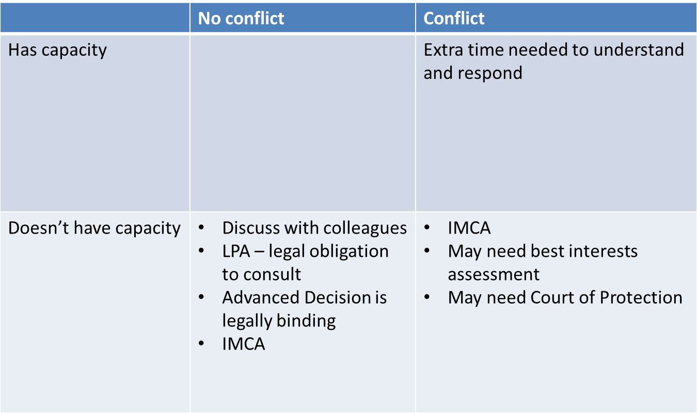
Simplest

The need for a unified community response to crisis

The need for immediate care and human company for people who appear to be dying presents a real issue for carers and paramedics, especially where they are not on an acute medical pathway or admitted to hospital. Currently they would have to wait up to four hours for assistance. Perhaps the palliative care team and CRRS (Community Rapid Response Service) will need expansion.

IBIS alerts are a useful indicator of patients becoming destablised in the community. On occasion SECAmb report that the Community Respiratory Team are able to respond to IBIS alerts and the respiratory nurse will already be with the patient supporting them when the ambulance arrives. Arguably IBIS alert information is a useful tool for primary care to plan their work for the day to minimise developing crisis but this would be most effectively done by a team who already understand the patient and have the time allowed to support them. Government calls for additional Sunday appointments will not address the issue of the medical crises developing in someone’s home. A response element should be integrated within a proactive care or complex needs team.

A single point of access by telephone to mobilise community teams is crucial. Paramedics and carers are currently calling all variety of numbers for district nurses, hospice and others who may be able to respond. Do we need a single point of access with knowledgeable and trained operators in order to mobilise appropriate help in a crisis?

The need for ethically sound outcome measures

Reasonable and effective outcome measures could include:
- Quality contingency plans uploaded to IBIS and ultimately available via SCRAI (Summary Care Record Additional Information)
- On-going audit of plans to ensure meeting the IBIS standard
- Significant event review (via ongoing audit) of each conveyance to hospital with an IBIS plan in place.
- Reporting, learning and implementing change based on outcome of these reviews
- Ultimately, offering an affordable means to appoint a legally binding LPA or write an Advanced Decision – ethically we will need to be confident the community can cope in a crisis if we are to promote this widely to patients.

The need to develop the skills and give time to GPs and clinicians

Experience has shown the need to develop the confidence to address issues that may not have been raised with people and their families. Culturally this is not an area that we ‘talk about’.
It is also clear that even for those with capacity and where there is no conflict with family and those close to the person, the discussion and completion of a contingency plan takes between one to two hours. Just as with procedures such as coil fitting, where we don’t ask GPs to fit it into a normal surgery, we need to schedule time for GPs to carry out contingency planning. It will not be successful without doing this.

